**Al-Driven Guest Experience Personalization System for Hospitality**

**Milestone 1 Documentation:**

**Introduction**

This documentation outlines the steps taken during the initial phase of the project *Personalization System for Hospitality*. The primary objective was to set up the project infrastructure, train the team, and prepare datasets for integrating sentiment analysis with CRM systems using Large Language Models (LLMs) like OpenAI GPT and Meta LLaMA.

**1. Environment Setup**

**Tools Used**

* **Integrated Development Environment (IDE):** We preferred the Visual Studio Code (VS Code) downloaded from google.
* **Programming Language:** Python 3.9
* **Libraries:** The preferred libraies are
  + For the data manipulation - pandas

Pip install pandas

* + For the OpenAI GPT API – openai

Pip install openai

* + For Meta LLaMA integration – transformers

Pip install transformers

* + For CRM API integration – requests

Pip install requests

* + For numerical operations – numpy

Pip install numpy

* + For managing environment variables – dotenv

Pip install python-dotenv

**Step-by-Step Setup**

1. **Install Python and VS Code**
   * Download and install Python from [Python.org](https://www.python.org/).
   * Install Visual Studio Code from [VS Code Official Site](https://code.visualstudio.com/).
2. **Environment Configuration**
   * Open VS Code and install the following extensions:
     + Python
   * Create a virtual environment using:
   * python -m venv env
   * env\Scripts\activate # On Windows – for activation
   * Installed required libraries:
   * pip install pandas openai transformers requests numpy python-dotenv
3. **Environment Variables**
   * Create a .env file to store sensitive API keys:
   * OPENAI_API_KEY=our_openai_api_key

**2. Dataset Creation**

**Mock CRM Interaction Dataset**

The dataset contains guest profiles and feedback data to simulate real-world CRM interactions.

1. **Define Dataset Structure**
   * **Customer feedback:**
     1. Customer Name
     2. Customer Mail ID
     3. Feedback
     4. Date and Time
     5. Caretaker/Server Name
     6. Care Employee ID
     7. Customer Age
     8. Customer Contact
     9. Sentiment (future analysis)
     10. Department
     11. Customer Stay Duration
     12. Number of Visits (Customer Past)
     13. Customer Membership Status
     14. Amount to be Paid
     15. NPS (Net Promoter Score)

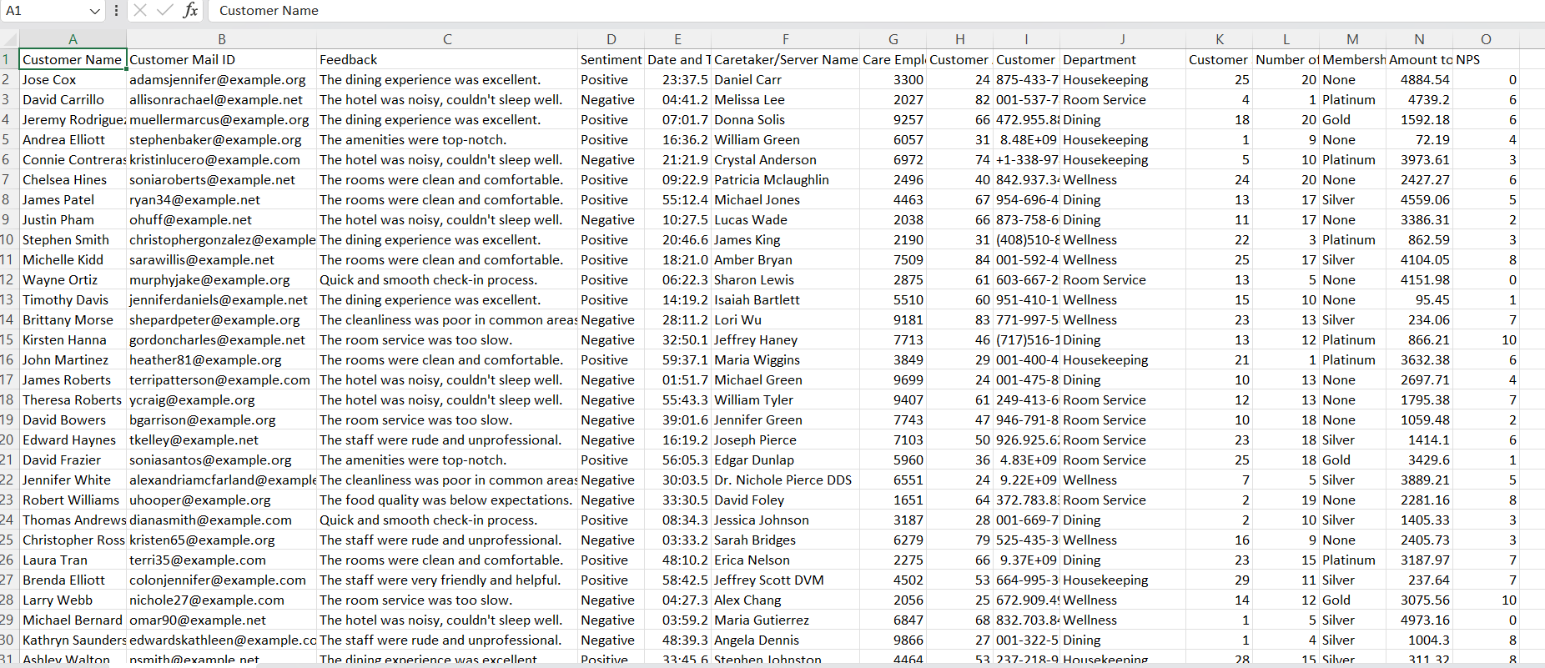

* + **Preferences:** 
    1. Dining (Vegetarian/Vegan)
    2. Room Preference
    3. Sports Activities (Table tennis, Golf, etc.)
    4. Wellness (Gym, Sauna, Massage)
    5. Pricing Patterns (Frugal/Luxury)

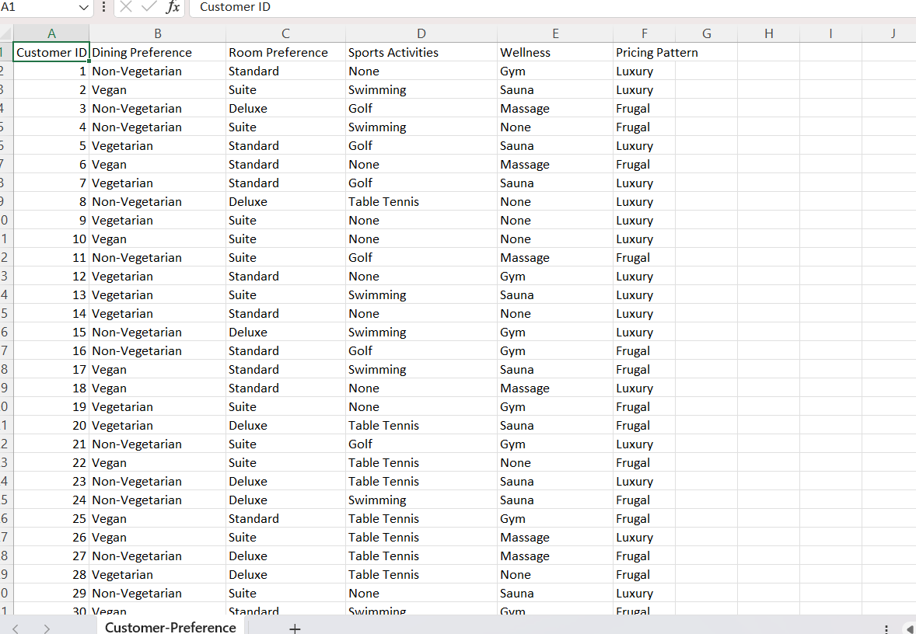

1. **Dataset Creation Code:** 
   * + For dateset we have preferred the Kaggle website to get realistic data , but we found some of the datasets.
     + We have collected some more feedbacks from chatgpt and we merged the both datasets.
     + And also we have collected the preferences seperately from gpt.
     + Step included :
       1. Go to kaggle.com website (.csv files)
       2. Search for required datasets related to project of guest experience feedbacks.
       3. We got some samples.
       4. To collect more feedbacks , go to chatgpt and search for data related to project.
       5. We have merged both the datasets.
       6. And also we have collected preferences also from chatgpt.

pip install pandas faker ( to create datasets)

* + - 1. And we got the datasets , which is more reliable of 10,000 samples.

**3. CRM Integration with LLMs**

**Objective**

Integrate CRM systems with LLMs to analyze guest feedback and provide sentiment analysis.

**Steps for Integration**

1. **Understand the CRM System**
   * Identify the CRM system in use.
   * Understand the data structure: guest profiles, feedback entries.
   * Obtain API documentation or access credentials for the CRM system.
2. **Set Up API Integration**
   * Authenticate with the CRM API using a secure method (API keys).
   * Test endpoints to retrieve guest profiles, feedback, and historical interaction logs.
   * Implement error handling for API calls to manage rate limits and server errors.
3. **Define Data Flow**
   * Establish a data pipeline to extract data from the CRM and preprocess it for LLMs.
   * Steps include:
     + **Data Extraction:** Fetch raw feedback and guest details from the CRM.
     + **Data Cleaning:** Remove duplicates, handle null values, and standardize text fields.
     + **Data Storage:** Store the cleaned data in a local database or cloud storage for analysis.
4. **Set Up the Sentiment Analysis Workflow**
   * Define the scope of analysis, such as:
     + Sentiment classification (Positive, Neutral, Negative).
     + Topic extraction (e.g., cleanliness, service, amenities).
   * Prepare prompts for LLMs to understand feedback and derive insights.
5. **Implement LLM Analysis**
   * Choose suitable LLMs based on the task:
     + **OpenAI GPT:** Fine-tuned for conversational and analytical tasks.
     + **Meta LLaMA:** Efficient for structured text analysis and summarization.
   * Develop workflows for batch and real-time analysis of CRM feedback.
6. **Post-Analysis Processing**
   * Format and store the results back into the CRM system or a dashboard.
   * Include insights such as:
     + Guest sentiment trends over time.
     + Frequent keywords in feedback.
     + Recommended actions for improving guest experience.
7. **Test the Integration**
   * Validate the accuracy of sentiment analysis on a sample dataset.
   * Compare outputs from OpenAI GPT and Meta LLaMA for quality and consistency.
   * Conduct edge-case testing (e.g., incomplete feedback, mixed sentiment).
8. **Deploy the System**
   * Implement the integration in a controlled environment.
   * Monitor API usage, system performance, and output accuracy.
   * Set up periodic reviews and feedback loops for system improvement.
9. **Team Training**
10. Introduction to LLMs and Project Goals
    * What are LLMs?
      + Overview of Large Language Models, their capabilities, and applications.
      + Examples: OpenAI GPT, Meta LLaMA, and their unique features.
    * Project Objectives:
      + Understand the role of LLMs in sentiment analysis for hospitality.
      + Learn how LLMs enhance guest experience by identifying sentiment and preferences.
11. Understanding the CRM System
    * Brief overview of the CRM platform being used.
    * Explanation of the data flow:
      + How guest profiles and feedback are stored and accessed.
      + API interaction with the CRM system for real-time data retrieval.
12. Environment Setup Workshop
    * Step-by-step walkthrough of the environment setup.
      + Installation of tools like Python, libraries, and VS Code.
      + Configuration of API keys in .env files.
    * Setting up a virtual environment and managing dependencies.
    * Running sample scripts to verify installations and integrations.
13. Mock Data Familiarization
    * Overview of the mock datasets (guest profiles, feedback):
      + Data fields and their significance.
      + Understanding relationships between guest profiles and feedback data.
    * Hands-on session to explore datasets:
      + Viewing datasets in CSV format.
      + Querying data using Python libraries like pandas.
14. LLM Basics and Prompt Engineering
    * Explanation of how LLMs process and analyze text.
    * Prompt Engineering Techniques:
      + Crafting prompts for specific tasks like sentiment analysis, topic extraction, and summarization.
      + Examples of good and bad prompts with outcomes.
    * Practice session with sample feedback data and LLMs like OpenAI GPT and Meta LLaMA.
15. Feedback Analysis Hands-On Session
    * Real-Time Examples:
      + Using OpenAI GPT to analyze feedback and classify sentiment.
      + Using Meta LLaMA for extracting key themes from feedback.
    * Guided exercises to test feedback with different sentiments:
      + Positive: “The staff was incredibly helpful.”
      + Negative: “The room was not clean, and the service was slow.”
      + Neutral: “The experience was average.”
    * Discussing the results and understanding how the model interprets sentiment.
16. Handling CRM Integration
    * Explanation of the API integration process:
      + Authenticating with the CRM system.
      + Retrieving and sending data through API calls.
    * Hands-on practice:
      + Writing and testing API requests using the requests library.
      + Implementing error handling for common issues like invalid credentials and rate limits.
    * Discussion on data privacy and security measures for CRM integration.
17. Error Handling and Debugging
    * Common issues during API calls and LLM analysis.
    * Debugging techniques using Python and VS Code tools.
    * Practical exercises for resolving API errors and interpreting unexpected LLM outputs.
18. Review and Feedback Session
    * Recap of the training sessions.
    * Group activity to analyze feedback and share insights.
    * Gathering feedback from team members on training effectiveness and areas for improvement.

**Conclusion**

The foundational setup for the project, including environment configuration, dataset creation, and CRM integration, has been successfully completed. Team members are now equipped to leverage LLMs for sentiment analysis in subsequent milestone 1.